

**Housing: Price Prediction**

Submitted by:

Siddharth Mukherjee

**ACKNOWLEDGMENT**

I express my sincere gratitude to Flip Robo Technologies for giving me the opportunity to work on this project on Housing Price prediction using machine learning algorithms. I would also like to thank Flip Robo Technologies for providing me with the requisite datasets to work with. I acknowledge my indebtedness to the authors of papers titled: “House Price Prediction using a Machine Learning Model: A Survey of Literature” and “The impact of housing quality on house prices in eight capital cities, Australia” for providing me with invaluable insights and knowledge of the dynamic relationships that exist in the economics of real estate and housing markets.

**INTRODUCTION**

* Business Problem Framing

Houses are one of the necessary needs of each and every person around the globe and therefore housing and real estate market is one of the markets which is one of the major contributors in the world’s economy. It is a very large market and there are various companies working in the domain. Data science comes as a very important tool to solve problems in the domain to help the companies increase their overall revenue, profits, improving their marketing strategies and focusing on changing trends in house sales and purchases. Predictive modelling, Market mix modelling, recommendation systems are some of the machine learning techniques used for achieving the business goals for housing companies. Our problem is related to one such housing company. A US-based housing company named Surprise Housing has decided to enter the Australian market. The company uses data analytics to purchase houses at a price below their actual values and flip them at a higher price. For the same purpose, the company has collected a data set from the sale of houses in Australia. The company is looking at prospective properties to buy houses to enter the market. You are required to build a model using Machine Learning in order to predict the actual value of the prospective properties and decide whether to invest in them or not. For this company wants to know:

• Which variables are important to predict the price of variable?

• How do these variables describe the price of the house?

* Conceptual Background of the Domain Problem

Predictive modelling, Market mix modelling, recommendation systems are some of the machine learning techniques used for achieving the business goals for housing companies.

Hedonic Characteristics of Housing Price: A Hedonic approach is preferred for predicting the sale prices in the housing market because the market displays resilience, flexibility and spatial fixity.

Housing Attributes: Studying the structural, locational, and economic attributes of housing properties is crucial in understanding their mutually inclusive relationships with their pricing.

* Review of Literature

2 research papers, namely: “House Price Prediction using a Machine Learning Model: A Survey of Literature” and “The impact of housing quality on house prices in eight capital cities, Australia” were reviewed and evaluated to gain insights into all the attributes that influence the price of house.

From studying the papers and analysing the research work it, is learnt that locational attributes and structural attributes are prominent factors in predicting house prices. Studies suggest that there exists a close relationship between House pricing and locational attributes such as distance from the closest shopping centre, train station, position offering views of hills or shore, the neighbourhood in which the property is situated etc.

Structural attributes of the house like lot size, lot shape, quality and condition of the house, garage capacity, rooms, Lot frontage, number of bedrooms, bathrooms, overall finishing of the house etc play a big role in influencing the house price.

Neighbourhood qualities can be included in deciding house price. Factors like efficiency of public education, community social status, the socio-cultural demographics improve the worth of a property.

The demand side of the housing market is also a necessary component. Although population growth is widely known as a driver in housing demand, the key issue lies in the proportion of people with abundant financial resources.

Variables representing land value such as rents and material costs also demonstrate their influence in explaining house prices, which are positively related to housing prices.

Multiple regression analysis models allow to ascertain price predictions by capturing independent and dependent variable data. In Using multiple regression modelling techniques, we can describe changes brought to a dependent variable with changes in the independent variables.

In this research, various models were built in which the house Sale Price is projected as separate and dependent variable while locational, structural and various other attributes of housing properties were treated as independent variables. Therefore, the house price is set as a target or dependency variable, while other attributes are set as independent variables to determine the main variables by identifying the correlation coefficient of each attribute.

* Motivation for the Problem Undertaken

There is a steady rise in house demand with every passing year, and consequently the house prices are rising every year. The problem arises when there are numerous variables such as location and property demand that influence the pricing. Therefore, buyers, sellers, developers and the real estate industry are keen to know the most important factors influencing the house price to help investors make sound decisions and help house builders set the optimal house price. There are many benefits that home buyers, property investors, and house builders can reap from the house-price model. This model aims to serve as a repository of such information and gainful insights to home buyers, property investors and house builders, that will help them determine best house prices. This model can be useful for potential buyers in deciding the characteristics of a house they want that best fits their budget and will be of tremendous benefit, especially to housing developers and researchers, to ascertain the most significant attributes to determine house prices and to acknowledge the best machine learning model to be used to conduct a study in this field.

**Analytical Problem Framing**

* Mathematical/ Analytical Modeling of the Problem

Various Regression analysis techniques were used to build predictive models to understand the relationships that exist between Housing sales prices and various Housing property attributes. The Regression analysis models were used to predict the Sale price value for changes in Housing property attributes.

Regression modelling techniques were used in this Problem since Sales Price data distribution is continuous in nature. In order to forecast house price, predictive models such as ridge regression Model, Random Forest Regression model, Decision tree Regression Model, Support Vector Machine Regression model, Extreme Gradient Boost Regression were used to describe how the values of Sale Price depended on the independent variables of various Housing property attributes.

* Data Sources and their formats

The dataset was compiled by a US-based housing company named Surprise Housing. The company has collected a data set from the sale of houses in Australia. The dataset was made available in .csv file format.

There are 2 datasets: One for training the predictive machine learning models and the second one to be used by the models for predicting the SalePrice(target variable).

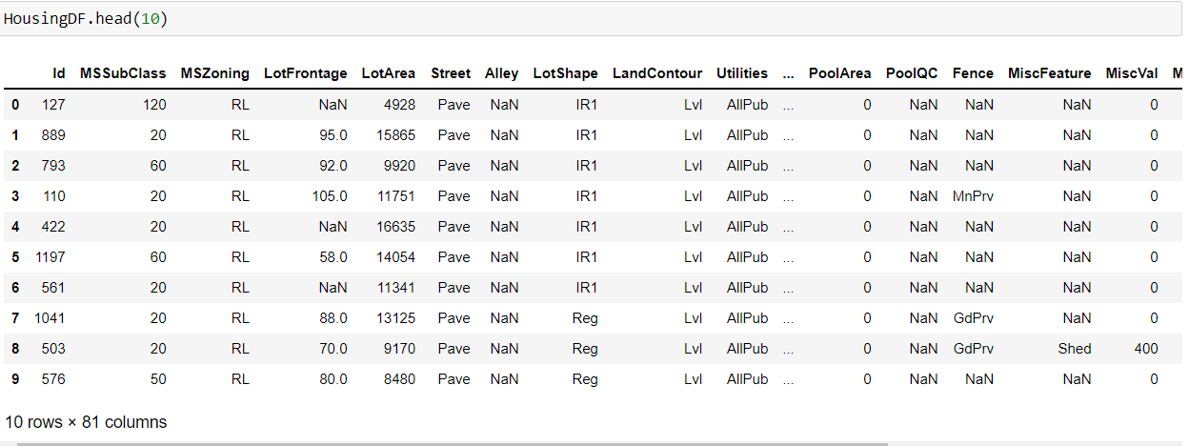

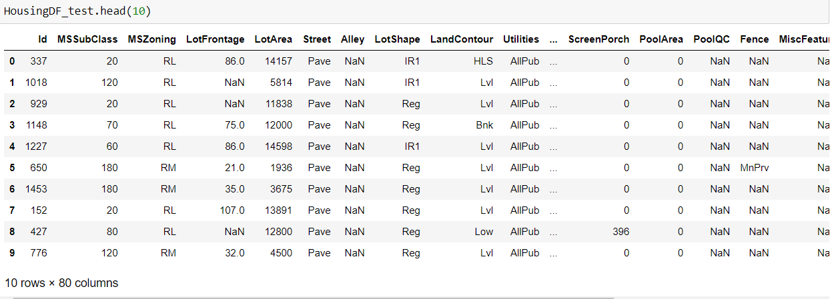

Training Dataset contains 1168 entries and 81 variables, while Test Dataset contains 292 entries and 80 variables.

**Dataset Description The Independent Feature columns are:**

MSSubClass: Identifies the type of dwelling involved in the sale.

MSZoning: Identifies the general zoning classification of the sale.

LotFrontage: Linear feet of street connected to property

LotArea: Lot size in square feet

Street: Type of road access to property

Alley: Type of alley access to property

LotShape: General shape of property

LandContour: Flatness of the property

Utilities: Type of utilities available

LotConfig: Lot configuration

LandSlope: Slope of property

Neighborhood: Physical locations within Ames city limits

Condition1: Proximity to various conditions

Condition2: Proximity to various conditions (if more than one is present)

BldgType: Type of dwelling

HouseStyle: Style of dwelling

OverallQual: Rates the overall material and finish of the house

OverallCond: Rates the overall condition of the house

YearBuilt: Original construction date

YearRemodAdd: Remodel date (same as construction date if no remodeling or additions)

RoofStyle: Type of roof

RoofMatl: Roof material

Exterior1st: Exterior covering on house

Exterior2nd: Exterior covering on house (if more than one material)

MasVnrType: Masonry veneer type

MasVnrArea: Masonry veneer area in square feet

ExterQual: Evaluates the quality of the material on the exterior

ExterCond: Evaluates the present condition of the material on the exterior

Foundation: Type of foundation

BsmtQual: Evaluates the height of the basement

BsmtCond: Evaluates the general condition of the basement

BsmtExposure: Refers to walkout or garden level walls

BsmtFinType1: Rating of basement finished area

BsmtFinSF1: Type 1 finished square feet

BsmtFinType2: Rating of basement finished area (if multiple types)

BsmtFinSF2: Type 2 finished square feet

BsmtUnfSF: Unfinished square feet of basement area

TotalBsmtSF: Total square feet of basement area

Heating: Type of heating

HeatingQC: Heating quality and condition

CentralAir: Central air conditioning

Electrical: Electrical system

1stFlrSF: First Floor square feet

2ndFlrSF: Second floor square feet

LowQualFinSF: Low quality finished square feet (all floors)

GrLivArea: Above grade (ground) living area square feet

BsmtFullBath: Basement full bathrooms

BsmtHalfBath: Basement half bathrooms

FullBath: Full bathrooms above grade

HalfBath: Half baths above grade

Bedroom: Bedrooms above grade (does NOT include basement bedrooms)

Kitchen: Kitchens above grade

KitchenQual: Kitchen quality

TotRmsAbvGrd: Total rooms above grade (does not include bathrooms)

Functional: Home functionality (Assume typical unless deductions are warranted)

Fireplaces: Number of fireplaces

FireplaceQu: Fireplace quality

GarageType: Garage location

GarageYrBlt: Year garage was built

GarageFinish: Interior finish of the garage

GarageCars: Size of garage in car capacity

GarageArea: Size of garage in square feet

GarageQual: Garage quality

GarageCond: Garage condition

PavedDrive: Paved driveway

WoodDeckSF: Wood deck area in square feet

OpenPorchSF: Open porch area in square feet

EnclosedPorch: Enclosed porch area in square feet

3SsnPorch: Three season porch area in square feet

ScreenPorch: Screen porch area in square feet

PoolArea: Pool area in square feet

PoolQC: Pool quality

Fence: Fence quality

MiscFeature: Miscellaneous feature not covered in other categories

MiscVal: $Value of miscellaneous feature

MoSold: Month Sold (MM)

YrSold: Year Sold (YYYY)

SaleType: Type of sale

SaleCondition: Condition of sale

**Target Column :**

Sale Price

* Data Preprocessing Done

**Checking for Null Values:**

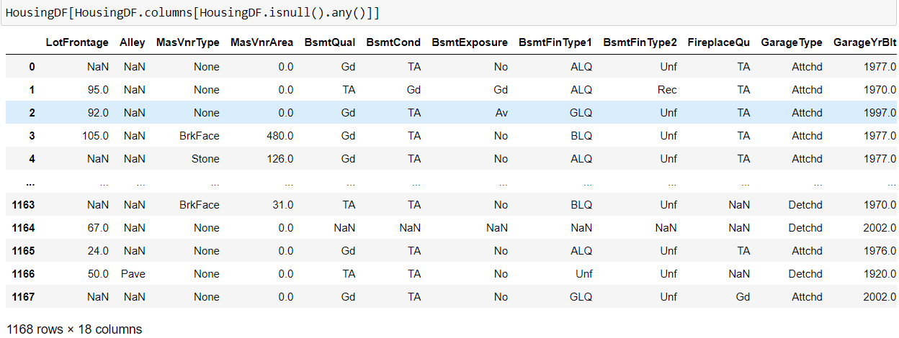

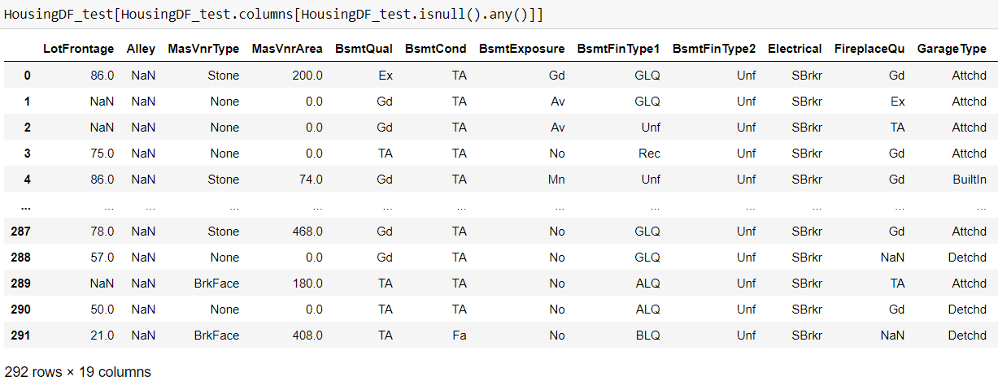

It’s observed that there are 18 columns in train dataframe with null values and 19 columns in test dataframe with null values.

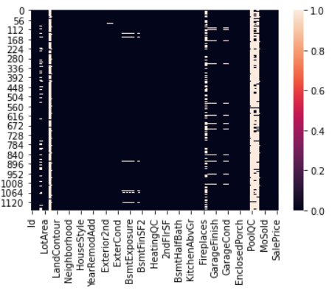

Plotting a heatmap of null values revealed that in both training and testing datasets, Columns titled: Alley, PoolQC,MiscFeature,FireplaceQu,Fence have extremely sparse data with overwhelmingly high percentage of null values and therefore must be dropped.

The ID columns from test and train datasets were also dropped since they don't contribute to building a good model for predicting the target variable values.

Finding the null value percentage in each of the columns in Train and Test datasets

Using the following codes, the percentage of null values in each column was determined to understand how sparse the data is in those columns and to decide upon which imputation techniques to use inorder to eliminate null values.

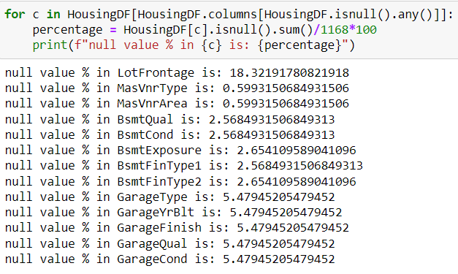

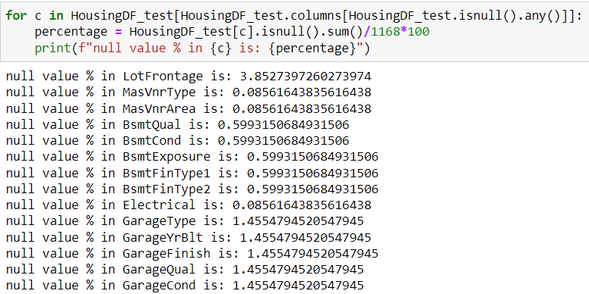

KNN imputation technique was used to impute values to missing data in LotFrontage, while the missing values in the rest of the columns were imputed with the most frequently occurring values of their respective columns.

* Data Inputs- Logic- Output Relationships

The Datasets consist mainly of object data type variables and a few float and int data type variables. The relationships between the independent variables and dependent variable were analysed Features like Lot area, Lot Frontage, Overall Quality, Overall Condition, Basement Finishing, Total Basement Surface Area, first and 2nd Floor square feet, Garage capacity,Total rooms have a positive linear relationship, therefore increase in their values leads to increase in SalePrice. Whereas Age of Housem Remodellling age Garrage age have a linear negative relationship and therefore increase in their values leads to a decrease in SalePrice.

* State the set of assumptions (if any) related to the problem under consideration

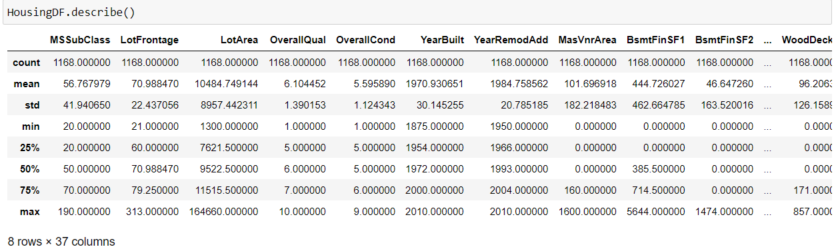

Based on the statistical information above, the following observations were made:

Big difference between max value and 75% in SalePrice,MSSubClass,LotFrontage,LotArea,BsmtFinSF1,BsmtF inSF2, etc indicates presence of outliers.

A higher std than mean in columns: MasVnrArea,BsmtFinSF1,BsmtFinSF2,WoodDeckSF,OpenPorc hSF,EnclosedPorch,3SsnPorch etc indicates presence of skewness.

An Anomaly is displayed in the relationship between age of house and SalePrice. There is a general negative relationship between House age and Sale Price, ie. increase in age leads to a decrease in SalePrice, however, houses built between 1880 and 1900 sold for the highest. The assumption made in this regard is that those houses were sold for the highest amount because of their antiquity value.

* Hardware and Software Requirements and Tools Used

**Hardware Used:**

Processor AMD Ryzen 9 5900HX(8 Cores 16 Logical Processors

Physical Memory: 16.0GB (3200MHz)

GPU: Nvidia RTX 3060 (192 bits), 6GB DDR6 VRAM, 3840 CUDA cores

**Software Used:**

Windows 10 Operating System

Anaconda Package and Environment Manager: Anaconda is a distribution of the Python and R programming languages for scientific computing, that aims to simplify package management and deployment. The distribution includes data science packages suitable for Windows and provides a host of tools and environment for conducting Data Analytical and Scientific works. Anaconda provides all the necessary Python packages and libraries for Machine learning projects.

Jupyter Notebook: The Jupyter Notebook is an open-source web application that allows data scientists to create and share documents that integrate live code, equations, computational output, visualizations, and other multimedia resources, along with explanatory text in a single document.

Python3: It is open source, interpreted, high level language and provides great approach for object-oriented programming. It is one of the best languages used for Data Analytics And Data science projects/application. Python provides numerous libraries to deal with mathematics, statistics and scientific function.

Python Libraries used:

Pandas: For carrying out Data Analysis, Data Manipulation, Data Cleaning etc Numpy: For performing a variety of operations on the datasets.

matplotlib.pyplot, Seaborn: For visualizing Data and various relationships between Feature and Label Columns

Scipy: For performing operations on the datasets o Statsmodels: For performing statistical analysis

sklearn for Modelling Machine learning algorithms, Data Encoding, Evaluation metrics, Data Transformation,Data Scaling, Component analysis,Feature selection etc

**Exploratory Data Analysis**

**Visualizations**

Barplots, Distplots, Boxplots, Countplots, lineplots were used to visualise the data of all the columns and their relationships with Target variable.

**Univariate Analysis**

**Analysing the Target Class:**

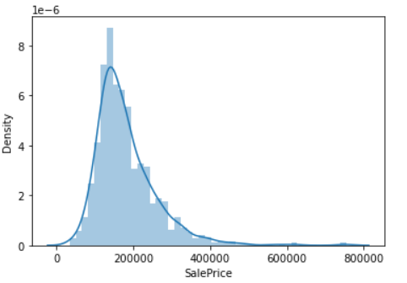

From the graph above it is observed that the Price data forms a continuous distribution with mean of 181477.00 and tails off from 400000 mark.

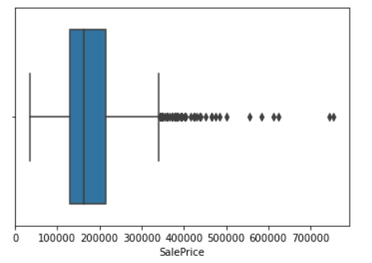

Distribution is skewed and contains outliers.

**Analysing the Feature Columns:**

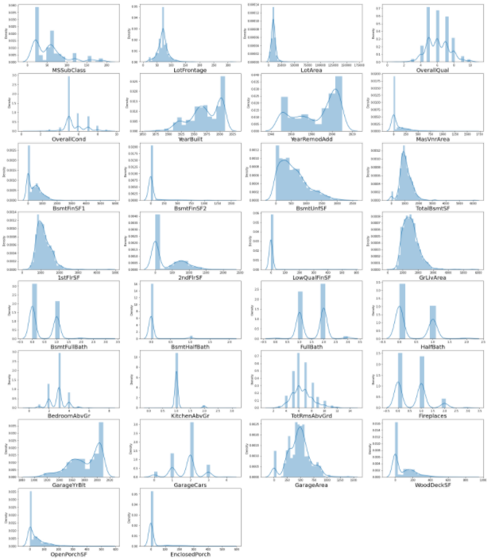

LotFrontage,LotArea,MasVnrArea,BsmtFinSF1,BsmtFinSF2,Bs mtUnFSF,TotalBsmtSF,1stFlrSF,2ndFlrSF,GrLivArea,WoodDeck SF,OpenPorchSF,EnclosedPorch are skewed and contain outliers

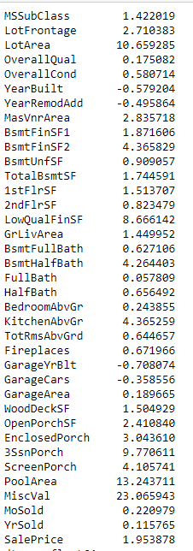

Considerable skewness exists in columns

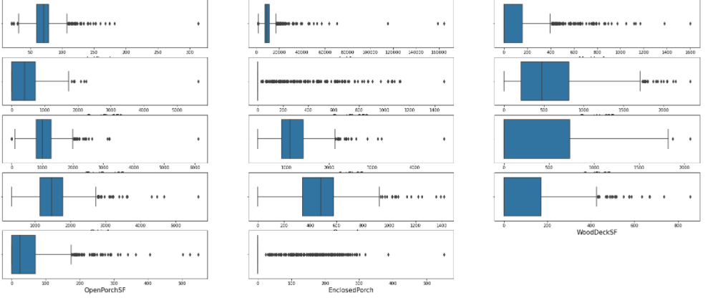

There is a considerable number of outliers in the columns. However, they will not be removed, since we have a very small dataset to work with and removing outliers results in 13.86% of loss in data.

**Normalizing Data Distribution using Power Transformer**

The skewness in Data Distributions of the feature columns was reduced using the Yeo-Johnson Power transformer method

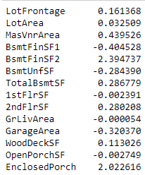

A lot of skewness has been removed.

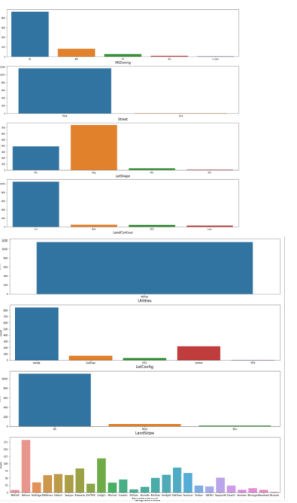

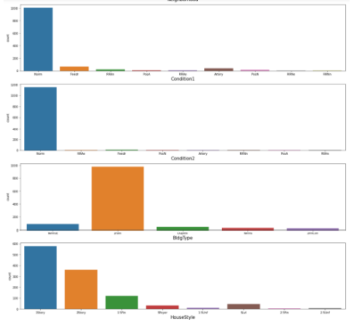

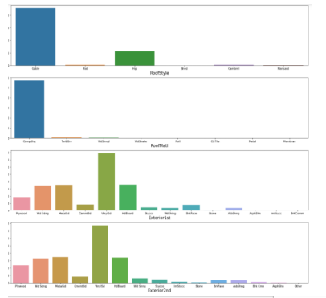

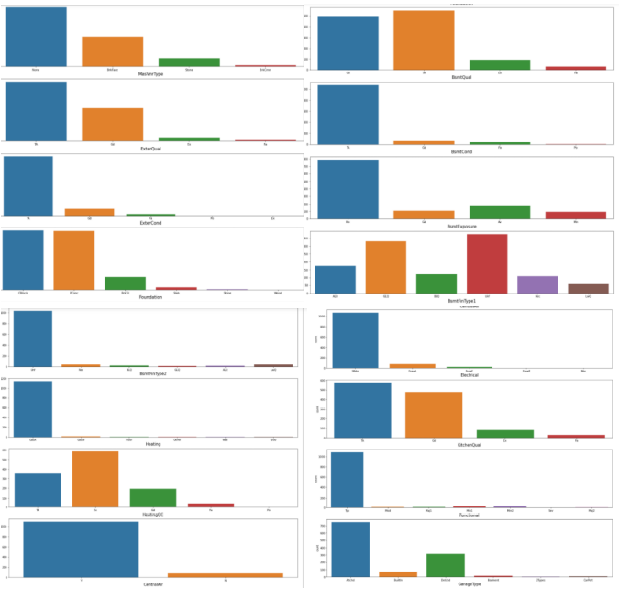

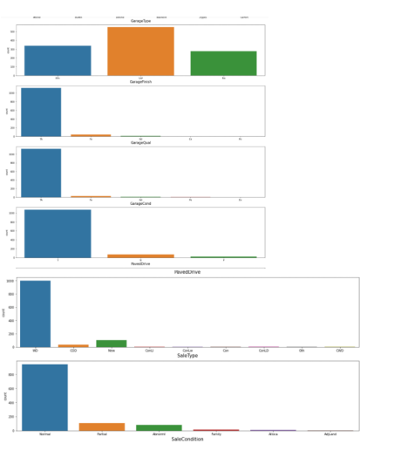

Following Observation are made from the above graphs:

Residential Low Density is the most common zoing classification

Most common Street Type is 'Pave'

Regular is the most common LotShape, followed by Slightly irregular

Most Properties have Near Flat/Level LandContour

All public Utilities are available

Inside lot is the most common Lot configuration

Slope of property land is most commonly gentle

Most Housing properties are situated in Neighborhoods of North Ames, followed by College Creek,Edwards and Old Town

Most Housing properties are in proximity to Normal conditions

Most Housing properties are of Single-family Detached type

Most Housing properties 1 storied and 2 storied o Most Houses have Gable roof style

Most Houses have roofs made of Standard (Composite) Shingle

Vinyl Siding is the most common exterior covering used

Most Houses don't have a Masonry veneer type while some have Brick Face

The quality of the material on the exterior is most commonly average/typical

The present condition of the material on the exterior is most commonly average/typical

Two of the most common foundation types are Cinder Block and Poured Concrete

The height of the basement is usually either Typical (80- 89 inches) or Good (90-99 inches)

The general condition of the basement is commonly Typical with slight dampness

Basements most commonly have no exposure

Most houses have Basements that are usually unfinished followed by houses with basements having Good Living Quarters

Most houses have Gas forced warm air furnace heating arrangement

Most houses have Excellent Heating quality and condition

Most houses have Central air conditioning

Most houses have Standard Circuit Breakers & Romex Electrical system

Most houses have Most houses have Typical/Average and Good Kitchen quality

Most houses have Typical Functionality

Most houses have a Garage Attached to home

Most houses have an Unfinished garage

Garage is usually Typical/Average

Garage condition is usually Typical/Average

Most houses have a Paved driveway

Warranty Deed - Conventional is the most common Type of sale.

**Bivariate Analysis**

Interpreting Relationship between Dependent Variable and Independent Variable Columns

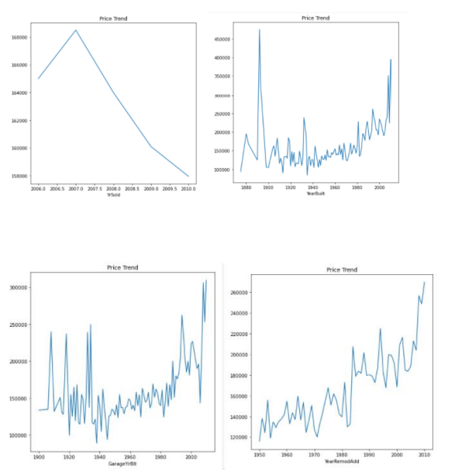

**From the graph above, it is observed that:**

Sales value peaked between 2006 and 2007 and there has been a general downward trend in sales price since then

Sales value is higher for houses built after 1990s implying the lesser the age of the house, the higher its value, however houses built between 1880 and 1900 sold for the highest, this could be because of their antiquity value

Sales value is higher for houses which were remodelled more recently.

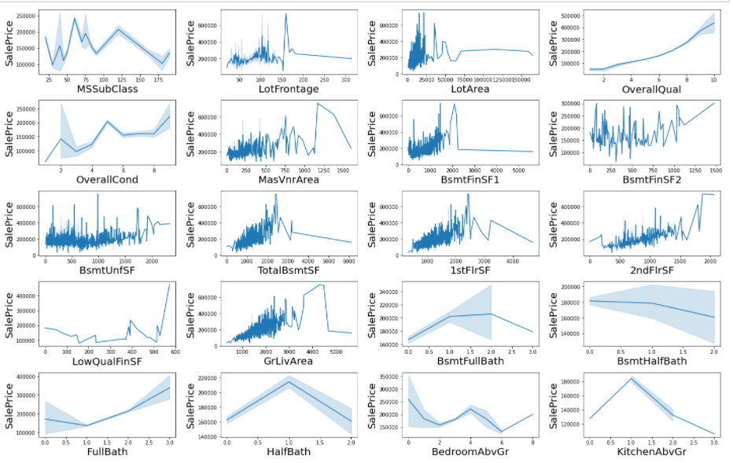

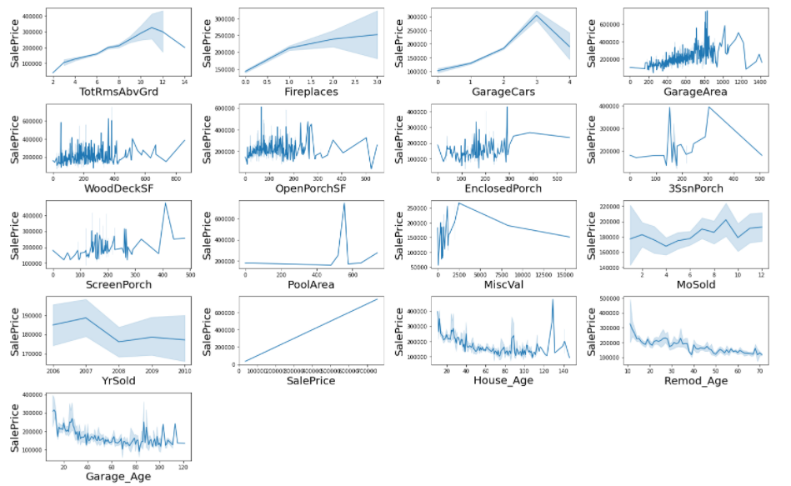

Following Observations are made from graphs above:

1 story and 2 and 2.5 story houses built in 1946 and newer fetch the highest amount in sales.

Houses with LotFrontage between 100 ft and 200 ft are sold for the highest amount.

Houses wtih Lot area upto 25000 sqft fetch the highest amount.

There is a Linear positive relation between Overall Quality and SalesPrice

There is a Linear positive relation between Overall Condition and SalesPrice

There is a Linear positive relation between Masonry veneer area and SalesPrice

Most Sales were done for Type 1 Finished basement with area upto 2500 sqft

There is a Linear positive relation between Type 2 Finished basement area and SalesPrice

There is a Linear positive relation between Total Basement area and SalesPrice

There is a Linear positive relation between Total 1st area and 2nd floor area and SalesPrice

There is a Linear positive relation between low Quality finished square feet and SalesPrice

There is a Linear positive relation between Above grade living area square feet and SalesPrice

There is a Linear negative relation between basment half bath and SalesPrice

There is a Linear positive relation between Full Bathroom and SalesPrice

There is a Linear positive relation between Total rooms above grade and SalesPrice

There is a Linear positive relation between Fireplaces and SalesPrice

There is a Linear positive relation between Garage Car capacity and SalesPrice

There is a Linear positive relation between Garage area and SalesPrice

Sales Prices peaked between 0-400 square feet area for Wooden Deck

Sales Prices peaked between 0-300 square feet area for Open Porch

Sales Price and Enclosed Porch area have a positive relation

Sales Price and 3 season Porch area have a positive relation

Sales Price and screen Porch area have a positive relation

Sales Price and Month Sold have a positive relation

Sales Price and Month Sold have a positive relation

Sales Price and house age have a negative relation

Sales Price and remodelling age have a negative relation

Sales Price and Garage age have a negative relation

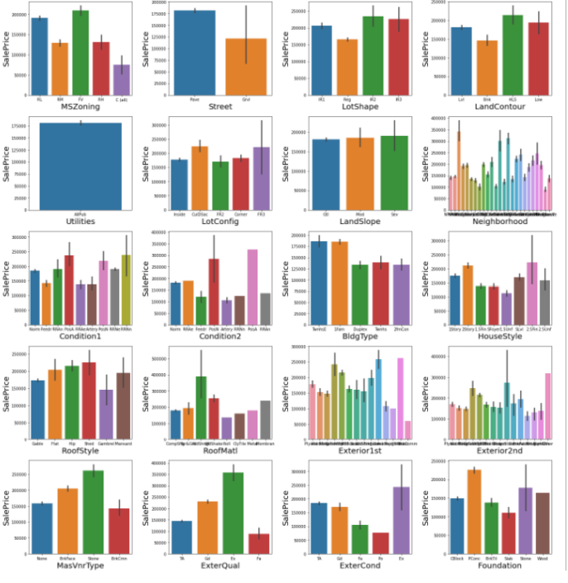

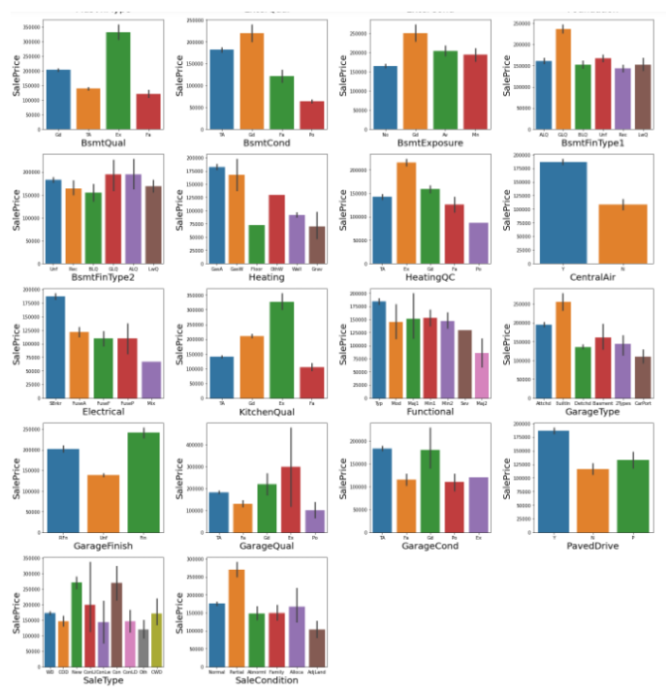

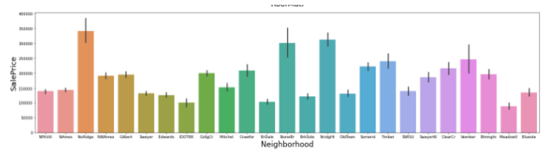

**Following Observations are made from graphs above:**

Saleprice is highest for Floating Village and Low density Residen tial zones

Saleprice is highest for housing properties near paved streets

Saleprice is highest for irregular lot shapes

Hill side properties sell for the highest amount

Utilities & Landslope columns don'tshow a strong relationship with Sales Price

Housing Properties in Northridge, Stone Brook,Northridge Heig hts,Timberland, Somerset,Veenker fetch the highest Sales amou nt

Cul-de-sac and 3 sided frontage lot configurations fetch the high est Sales amount

Proximity to Railroads, Off-site features like parks etc fetch the highest Sales amount

Townhouse and Single-family Detached are the most valued

Two story and Two and one-half story: 2nd level finished sell for the highest amount

Houses with Wood Shingle Roofs sell for the highest amount

Houses with Exterior covering of Cement Board,Stone,Imitation Stucco sell for the highest amount

Houses with Stone Mason veneer type sell for the highest amou nt

Houses with Excellent exterior material quality sell for the highe st amount

Houses with Excellent exterior material condition sell for the hig hest amount

Houses with Poured Concrete and stone foundation types sell f or the highest amount

Houses with Excellent (100+ inches) height of the basement sell for the highest amount

Houses with Excellent Basement Condition sell for the highest a mount

Houses with Good Basement Exposure sell for the highest amount

Houses with Good and Average Living Quarters in Basement sell for the highest amount

Houses with Gas forced warm air furnace and Gas hot water he ating systems sell for the highest amount

Houses with Excellent Heating quality and condition sell for the highest amount

Houses with Central Air Conditioning sell for the highest amoun t

Houses with Standard Circuit Breakers & Romex sell for the high est amount

Houses with Excellent Kitchen Quality sell for the highest amou nt

Houses with Built in Garages sell for the highest amount

Houses with Good / Typical Garage condition sell for the highest amount

Houses with Finished Garage sell for the highest amount

Houses with excellent Garage Quality sell for the highest amoun t

Houses with Paved Driveway sell for the highest amount

Homes just constructed and sold, Contract 15% Down payment regular terms sell for the highest amount

New Homes(not completed when last assessed) sell for the high est amount

**Multivariate Analysis**

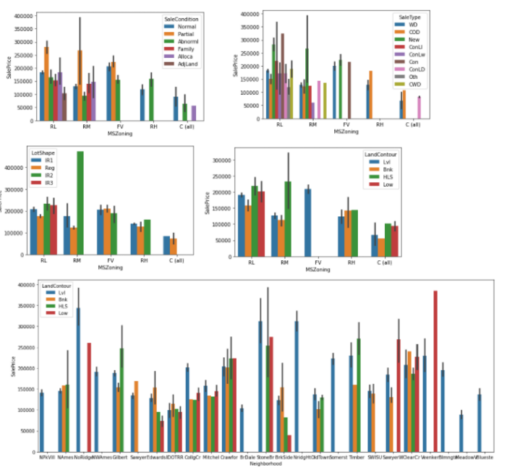

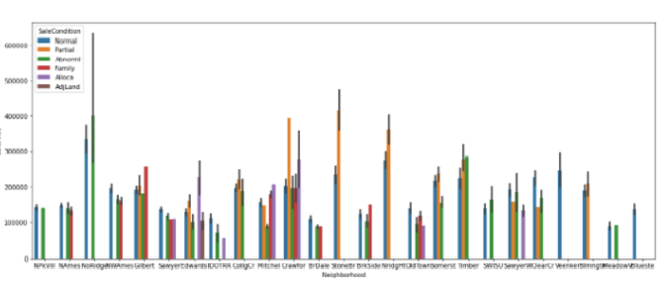

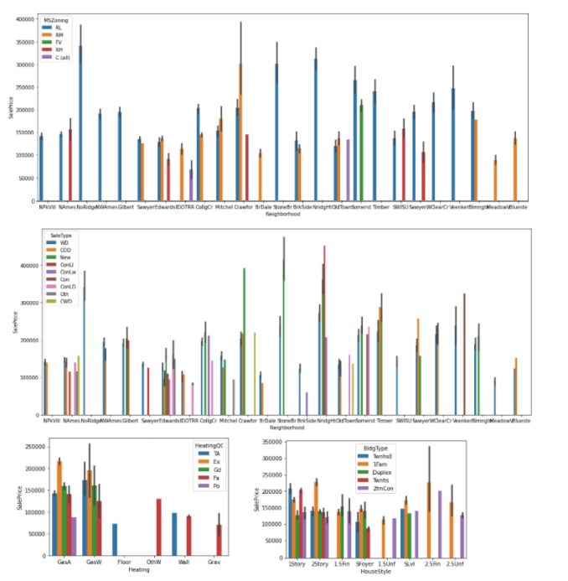

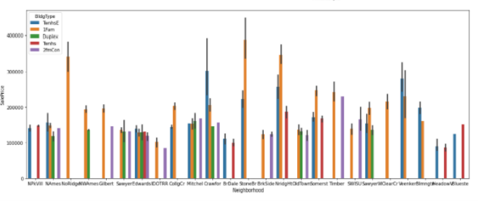

Following Observations are made from graphs above:

New Homes are the most popular in all types of zoning

New hourses and Low interest contract are the most popular sale types in low density, medium density and floating village residentials

Partially irregular and irregular plot shapes are most popular in low and medium residential zone

Low density and medium density zones settled near hillsides and depressions are mostly sold at higher prices, whereas floating villages are settled in flat regions, and high density zones settle near banked regions sell for the highest prices

Most housing properties established in levelled regions in North Ridge sell for the highest.

Most Housing properties in levelled regions of Stone Brook sell for highest followed by banked region and hillsides

Houses in levelled region of NorthRidge heights sell for the most while housing properties in depressed regions of Veenker sell for the highest prices.

Most housing properties that are newly established in Crawford,Stone Brook, Timberlane,North Ridge Heights,Bloomington Heights sell for the highest.

Most Housing properties in North Ridge sell for trade, foreclosure, short sale and normal sale in North Ridge.

Most houses sold in North Ridge,North Ridge Heights, Somerset,TimberLane,Veenker, Bloomington Heights are in low density residential zones.

North Ames has more houses sold in High density residential zones, while Crawford has more houses sold in medium density residential zones.

Warranty Deed - Conventional,Home just constructed and sold,Contract Low InterestCourt Officer Deed/Estate are the most common sale types.

**Feature Engineering:**

In order to better understand the relationships between age of a housing property and SalePrice, following columns were created based on data of existing columns:

House Age data was extracted from YearBuilt, and was placed in new column titled: House_Age, House Remodeling Age was extracted from YearRemodAdd, and was placed in new column titled: Remod_Age and age of Garage was extracted from GarageYrBuilt nd placed in a new column titled Garage_Age.

**Encoding the Categorical Columns:**

Before Proceeding with finding the correlations of the columns, The data of the categorical columns needs to be encoded using LabelEncoder

**Finding the correlations** : Visualizing correlation of Feature Columns with Label Column

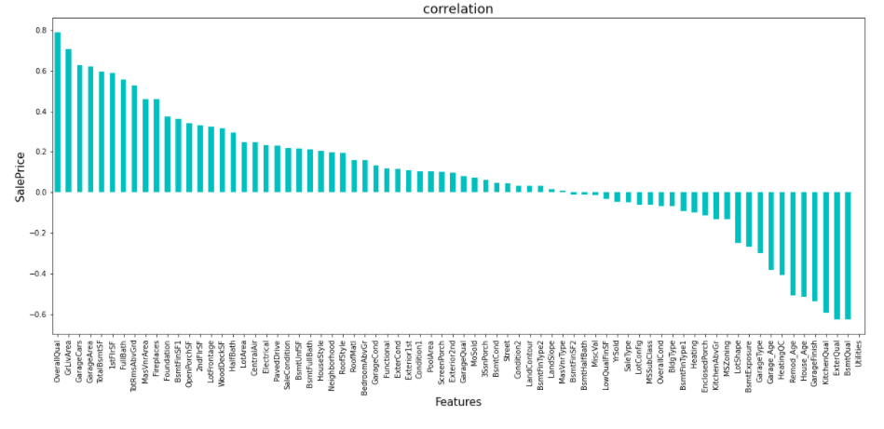

OverallQual,GrLiveArea,GarageCars,GarageArea,TotalBsmtSF,1stFlrSF,Full Bath,TotRmsAbvGrd,MasVnrArea,FirePlaces have the strongest positive correlation with SalePrice while BsmtQual,ExterQual,KitchenQual,GarageFinish,House_age,Remod_age,H eatingQC,Garage_age have the strongest negative correlation with SalePrice.

**Model/s Development and Evaluation**

**Feature Selection**

Features were first checked for presence of multicollinearity and then based on Principle Component Analysis and based on the respective ANOVA f-score values, the feature columns were selected that would best predict the Target variable, to train and test machine learning models.

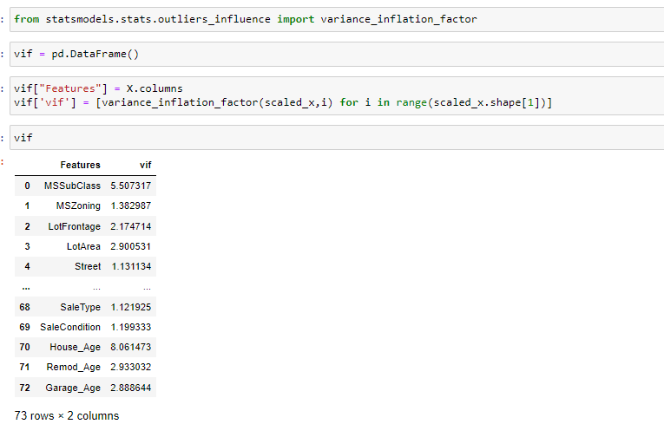

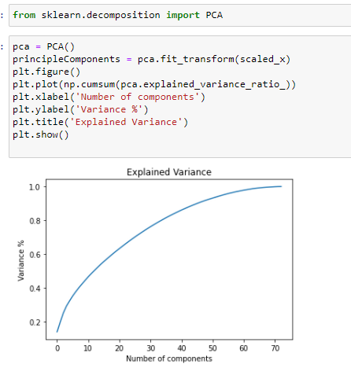

Based on The Principle Component Analysis it was determined that 70 components explain around 95% variance in Data

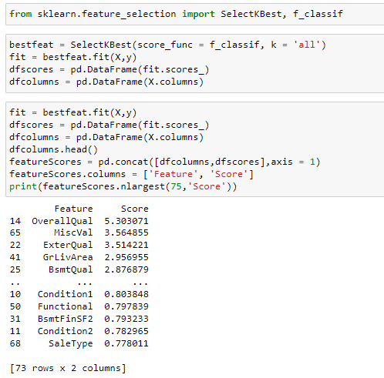

Using SelectKBest and f_classif for measuring the respective ANOVA f-score values of the columns, the best 70 features were selected.

Using StandardScaler, the features were scaled by resizing the distribution values so that mean of the observed values in each feature column is 0 and standard deviation is 1.

From sklearn.model_selection’s train_test_split, the data was divided into train and test data. Training data comprised 75% of total data where as test data comprised 25% based on the best random state that would result in best model accuracy.

Inorder to find the best random state for the train and test split, the following code was used

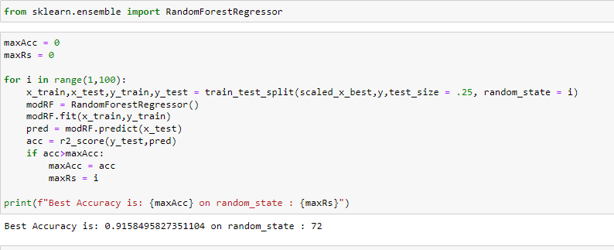

**The model algorithms used were as follows:**

**Ridge:** Ridge regression is a model tuning method that is used to analyse any data that suffers from multicollinearity. This method performs L2 regularization. Since the features have multicollinearity occurs, least-squares are unbiased, and variances are large, this results in predicted values to be far away from the actual values. Ridge shrinks the parameters. Therefore, it is used to prevent multicollinearity.

**DecisionTreeRegressor:** Decision Tree solves the problem of machine learning by transforming the data into a tree representation. Each internal node of the tree representation denotes an attribute and each leaf node denotes a class label.A decision tree does not require normalization of data. A decision tree does not require normalization of data.

**XGBRegressor**: XGBoost uses decision trees as base learners; combining many weak learners to make a strong learner. As a result it is referred to as an ensemble learning method since it uses the output of many models in the final prediction. It uses the power of parallel processing,supports regularization, and works well in small to medium dataset

**RandomForestRegressor**: A random forest is a meta estimator that fits a number of classifying decision trees on various sub-samples of the dataset and uses averaging to improve the predictive accuracy and control over-fitting. A random forest produces good predictions that can be understood easily. It reduces overfitting and can handle large datasets efficiently. The random forest algorithm provides a higher level of accuracy in predicting outcomes over the decision tree algorithm.

**Support Vector Regressor:** SVR works on the principle of SVM with few minor differences. Given data points, it tries to find the curve. But since it is a regression algorithm instead of using the curve as a decision boundary it uses the curve to find the match between the vector and position of the curve. Support Vectors helps in determining the closest match between the data points and the function which is used to represent them. SVR is robust to the outliers. SVR performs lower computation compared to other.

**Regression Technique:**

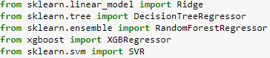

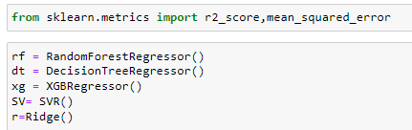

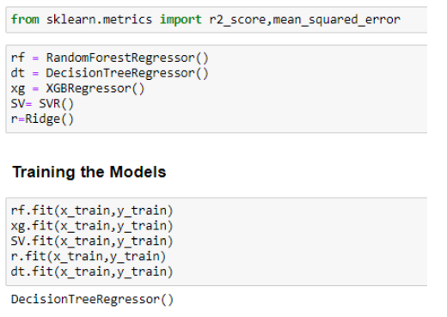

Mean Squared Error and Root Mean Squared Error metrics were used to evaluate the Model performance. The advantage of MSE and RMSE being that it is easier to compute the gradient. As, we take square of the error, the effect of larger errors become more pronounced than smaller error, hence the model can now focus more on the larger errors.

Cross validation is a technique for assessing how the statistical analysis generalises to an independent data set. It is a technique for evaluating machine learning models by training several models on subsets of the available input data and evaluating them on the complementary subset of the data. Using cross-validation, there are high chances that we can detect over-fitting with ease.

Model Cross Validation scores were then obtained for assessing how the statistical analysis generalises to an independent data set. The models were evaluated by training several models on subsets of the available input data and evaluating them on the complementary subset of the data

**Interpretation of the Results:**

Based on comparing Accuracy Score results with Cross Validation results, it is determined that Random Forest Regressor is the best model. It also has the lowest Root Mean Squared Error score.

**CONCLUSION**

* Key Findings and Conclusions of the Study

Based on the in-depth analysis of the Housing Project, The Exploratory analysis of the datasets, and the analysis of the Outputs of the models the following observations are made:

Structural attributes of the house Structural attributes of the house like lot size, lot shape, quality and condition of the house, garage capacity, rooms, Lot frontage, number of bedrooms, bathrooms, overall finishing of the house etc play a big role in influencing the house price.

Neighbourhood qualities can be included in deciding house price.

Various plots like Barplots,Countplots and Lineplots helped in visualising the Feature-label relationships which corroborated the importance of structural and locational attributes for estimating Sale Prices.

Due to the Training dataset being very small, the outliers had to be retained for proper training of the models.

Therefore, Random Forest Regressor, being robust to outliers and being indifferent to non linear features, performed well despite having to work on small dataset.

**Limitations of this work and Scope for Future Work**

While features that focus on structural and locational attributes of housing properties are crucial for estimating the Sale Price of Housing properties, they aren’t the only factors that influence the value in the housing market. Data on Demographics(Age,Income,Regional preferences of buyers, purpose of buying a property) is very important for understanding the Housing market. Interest Rates too impact the price and demand of houses. Economic cycles also influence Real Estate prices. Government Policies, Regulations, Legalizations are also important factors that may influence the sales of houses. The availability of data on above features would help build a predictive model that would more accurately understand the relationship between the features and target variable and yield more accurate prediction.